 | CAMECA IMS 7f and 4f-E7  Post acceleration  Ref 00 45 633 995 - type 108 – Indice A-
0000.doc
Index

Contents

1. Introduction to the post-acceleration 3
1.1 Principle 3
1.2 Functions 3
2. Post-acceleration system features 4
3. Hardware description 5
3.1 Mechanical assembly 5
3.2 Main power and control chassis 6
3.3 EM preamplifier 6
3.3.1 Deadtime adjustment 7
4. Post-acceleration control mode 8
4.1 Post-acceleration parameters 8
4.2 Access to the post-acceleration parameters 8
4.3 High voltage safety 9
5. Pulse height distribution 9
5.1 EM signal output 9
5.2 Pulse height distribution: main features 9
5.3 Pulse height distribution: EM high voltage effect 10
5.4 Pulse height distribution: mass species effect 11
5.5 Pulse height distribution: secondary extraction voltage effect 12
5.6 Pulse height distribution: post-acceleration voltage effect 13
5.7 Pulse height distribution record 14
5.7.1 Recording a PHD in automatic mode 14
5.7.2 The EM PHA main box 15
5.7.3 The EM PHA Measurement Parameters Box 16
5.7.4 The EM PHA Curve Box 17
6. Post-acceleration tuning 17
6.1 Basic instrument tuning 17
6.1.1 EM high voltage setting 17
6.1.2 The EM HV main box 18
6.1.3 The EM HV Measurement Parameters Box 19
6.1.4 Principle of the EM HV routine 19
6.1.5 Threshold setting 20
6.2 Post-acceleration setting 20
7. Maintenance and troubleshooting 20
7.1 Maintenance 20
7.2 Troubleshooting 21

Introduction to the post-acceleration

Principle
CAMECA SIMS instruments are equipped with an electron multiplier (EM) to measure secondary ions intensity with a very low background and high dynamic range.
The ion / electrons conversion yield of the first dynode of electron multiplier varies with the velocity of the impinging secondary particles. The higher the velocity the higher the electron multiplier detection quantum efficiency (DQE). On CAMECA SIMS instruments, the EM first dynode is grounded and therefore the velocity of secondary particles is fixed by both their mass and the secondary accelerating voltage. It results that :
- When low extraction voltages have to be used (in-depth profiling at very high depth resolution), the EM yield decrease due to a lower impact energy of the secondary particles onto the first dynode reduces the instrument sensitivity.
- At constant extraction voltage, the DQE varies as a function of the mass. This mass fractionation can be as large as several tens of percents between light and heavy species. It can be noticed that this mass fractionation effect also exists between isotopes, and must not be neglected for accurate isotope ratios measurements.
These two above mentioned limitations of EM detector performance can be strongly reduced by post-accelerating the impinging secondary particles just before reaching the first dynode. Actually, in this way the secondary ion impact energy onto the first dynode is adjustable at a value consistent with a high DQE whatever the choice of the secondary extraction voltage. And, at given extraction voltage, the post-acceleration reduces the mass fractionation. Note that there is a practical limit for the post-acceleration effect due to electronic noise induced by the high voltage applied on the electron multiplier.
A post acceleration system for electron multiplier has been therefore developed to improve the performance of the detection system of CAMECA SIMS instruments.
Contents ↑

Functions
The basic principle of the post-acceleration system developed for IMS xf instruments is represented in Fig. 1. It is worthwhile to notice that the preamplifier/discriminator system has been designed to be compatible with the electron multiplier floating at a high voltage. With this new design, two features have also been introduced :
- the dead time of the counting system is electronically fixed by means of delay lines and is therefore very stable. Accurate dead time correction can be applied when the electron multiplier has to be used at high count rate.
- the preamplifier is compatible with a software function which allows to record pulse height distribution. This is a very valuable capability to accurately monitor the gain stability of the EM, and to decide of the setting of both EM high voltage and discriminator threshold.
Figure 1 : Schematic representation of the EM post-acceleration.
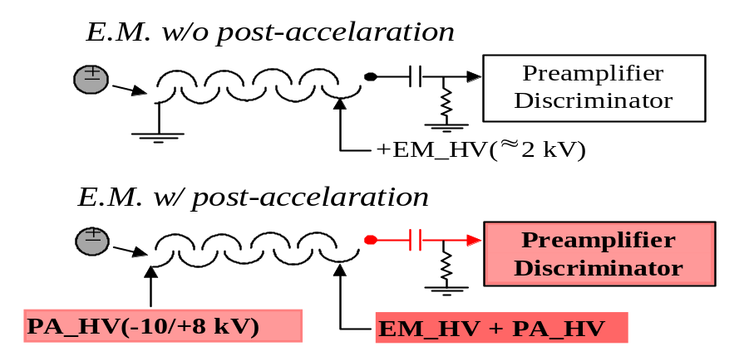
The data plotted in Fig. 2 demonstrate the efficiency of the post-acceleration system for different species. They show that a post-acceleration voltage of 6 kV maintains the EM yield above 70 % for all analyzed species. For instance, for ⁷⁴Ge⁻ species, an EM yield improvement by a factor of 4 is thus provided compared to a configuration with no post-acceleration. Note that this measurement series has been performed with a fixed discriminator threshold value optimized for 5 kV post acceleration voltage. It must be emphasized that the amplitude of the EM yield improvement depends on the age of the EM : the newer the EM, the lower the EM gain improvement. Data shown in Fig. 2 correspond to an EM used for several months.
Figure 2 : EM yield as a function of the post acceleration voltage for different species.
Secondary extraction voltage : -1 kV.
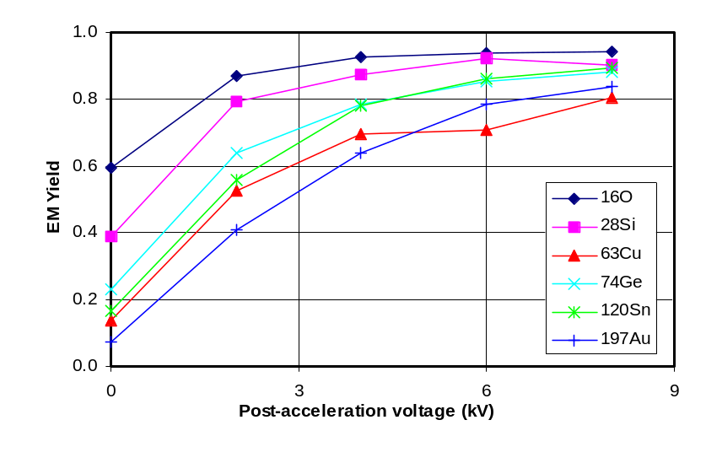
Contents ↑

Post-acceleration system features
- The post acceleration voltage supply can run from -10 kV up to + 10 kV. However, the recommended range for the post acceleration voltage is -10 kV up to + 8 kV.
- EM background at post-acceleration voltage below ± 6 kV: less than 5 c/mn.
- EM pre-amplifier with electronically fixed dead time: 5 dead time values selected by means of a jumper between 20 and 40 ns.
- Electron multiplier and post-acceleration high voltages control: computer controlled through the IMS 7f dedicated keyboard. Software option for electron multiplier high voltage determination.
- Discriminator threshold: computer controlled. Software option for pulse height distribution monitoring.

Hardware description
The post-acceleration system consists of a mechanical assembly (housing of the EM, high voltage isolation), an electronic chassis (power supplies, control units) and the preamplifier/discriminator assembly. They are described in the three next sections (§3.1, 3.2, 3.3).
Contents ↑

Mechanical assembly

Fig. 3 shows the post-acceleration system mounted on a CAMECA IMS 7f instrument.
Figure 3 : Post-acceleration system mounted on a CAMECA IMS 7f.
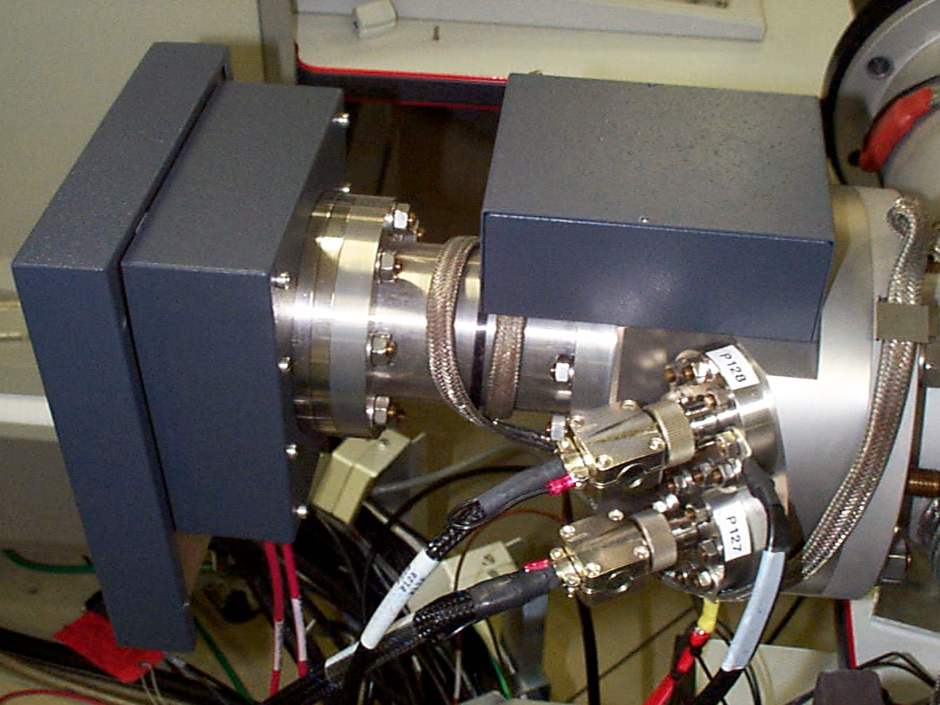
Housing of the electron multiplier
Preamplifier
Housing of the high voltage feedthrough and coupling system
A mechanical drawing of the post-acceleration system is given in Fig. 4. It shows the main components which are:
- the high voltage feedthroughs to apply both the EM and post-acceleration voltages and to measure the output signal.
- the shield of the electron multiplier. This shield is brought at the post-acceleration voltage in order to eliminate the risks of arcing problems between the electron multiplier and the housing of the system, and to define the electrical field shape at the EM first dynode level.
Figure 4 : Mechanical drawing of the post-acceleration system.
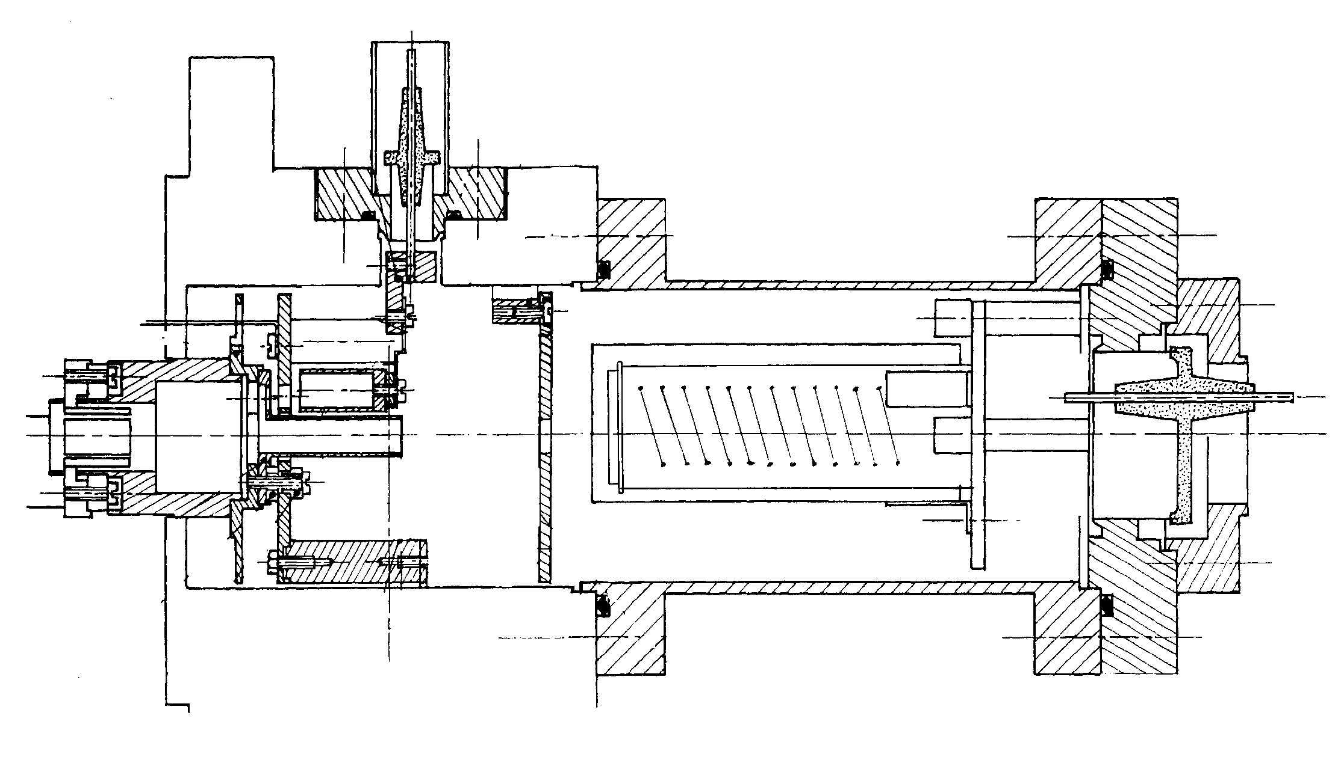
Electron multiplier
Electron multiplier shield
High voltage feedthrough
Grounded plate
Standard Faraday cup
Contents ↑

Main power and control chassis
The post-acceleration system is delivered with one control chassis. The main power switch is located at the rear of the chassis. All the post-acceleration parameters are adjusted through the dedicated keyboard.
Contents ↑

EM preamplifier
The preamplifier / discriminator assembly is shown in Fig. 5. It can be noticed that the preamplifier and the discriminator are independently shielded in order to reduce the electronic noise of the overall system.
Contents ↑

Figure 5 : Preamplifier / discriminator assembly.
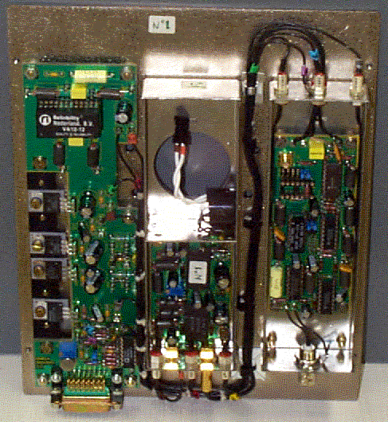
Discriminator
Preamplifier
Jumper for dead time value adjustment
Interface
Coupling system

Deadtime adjustment
The dead time value is adjustable by positioning a jumper. The available dead time values are: 20, 24, 28, 36, and 40 ns. Fig. 5 shows the location of the jumper. The jumper label on the board is TB2. The jumper position corresponding to 20 ns is at the top.
The dead time value is the sum of the delay time (determine by the delay line) and the extra time for the signal propagation.
Dead Time = 2* delay_line + 4ns (propagation time)
Dead time (ns) | Delay line (ns) | Jumper position
72 | 34 | TB 21 #1
64 | 30 | TB 22 #1
80 | 38 | TB 23 #1
88 | 42 | TB 24 #1
48 | 22 | TB 25 #1
28 | 12 | TB 21 #3
32 | 14 | TB 22 #3
24 | 10 | TB 23 #3
40 | 18 | TB 24 #3
20 | 8 | TB 25 #3
For most of the applications the jumper position TB 23 #3 is recommended.

Post-acceleration control mode

Post-acceleration parameters
The tuning of the post-acceleration system requires the control of the 4 parameters as follows:
- Electron multiplier voltage. Range: 0 to 3000V (always positive polarity).
- Post-acceleration voltage polarity.
- Post acceleration voltage. Range 0 to 10kV. Note that when the post-acceleration polarity is positive (negative secondary voltage), it is recommended not to apply more that + 8kV post-acceleration voltage in order to keep the electron multiplier background below 10 c/mn.
- Preamplifier discriminator threshold. Range: +50mV to -2 V.
The two following sections describe how to control the value of these parameters for the IMS 7f configuration.
Contents ↑

Access to the post-acceleration parameters

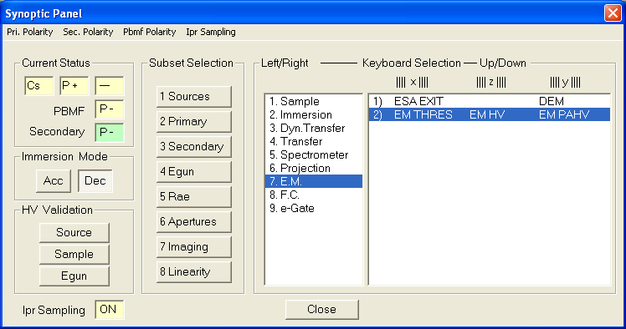
Post-acceleration voltage
EM high voltage
Discriminator threshold
Secondary polarity (post-acceleration polarity is of opposite sign)

The EM high voltage parameter is stored in the instrument setup file. It belongs neither to the EM preset, nor to the ISF file. It is written in the setup file whenever the ISF file is saved (Tuning program of the CAMECA IMS 7f software).
The EM Post-acceleration voltage parameter is stored in each ISF file (Tuning program of the CAMECA IMS 7f software).
Note that the voltage display correspond to the commands sent to the micro-controllers. In case of electronics troubleshooting, these values can be different from the ones measured with a voltmeter on the hardware.
Contents ↑

High voltage safety

The EM and post-acceleration voltages are controlled by the HV safety system. Thus, they cannot be set ON if:
- the analysis chamber gate valve is closed,
- the vacuum in the mass spectrometer is not good enough (< 10⁻⁶ T).
Contents ↑

Pulse height distribution

EM signal output

Due to the statistical variation of the secondary electron emission, every secondary ion reaching the first dynode of the electron multiplier does not produce the same number of electrons. This first "pulse" of electrons is amplified by the successive stages the electron multiplier with a gain in the range of 10⁸. The pulses detected at the EM output do not have the same amplitude (see Fig. 6) and, for a given species, the pulse height distribution depends on both ion /electron conversion efficiency and EM gain. The knowledge of this distribution is therefore very helpful to optimize the setting of the electron multiplier parameters.
Figure 6 : Basic principle of the EM signal output.
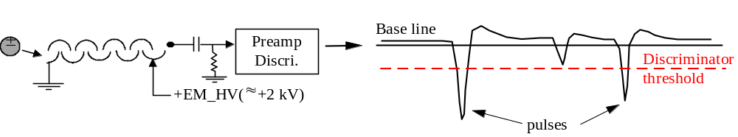Contents ↑

Pulse height distribution: main features
Fig. 7 shows an example of a pulse height distribution recorded for Si⁺ ions. For an ease of data reading, it is used to plot the derivative curve of a pulse height distribution,
i.e. - d(Intensity)/d(threshold voltage) vs. - threshold voltage.
Figure 7 : Pulse height distribution for Si⁺ with 5 keV impact energy on the fist dynode.
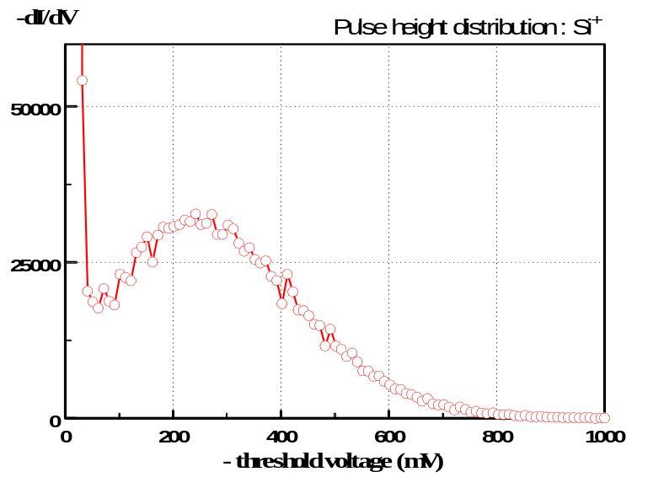
Noise
Maximum of the PHD
Threshold setting
PHD valley
Three main features can be observed on such pulse height distribution (PHD):
- Noise: this is the first part of the curve. It corresponds to the low amplitude pulses. They are generated by "parasitic" particles (secondary electrons, dynode outgasing.....). Note that part of these particles are generated by the impact of the secondary particles and/or the electrons cascades on the dynodes. These small amplitude pulses are eliminated by means of the discriminator threshold.
- Maximum of the PHD: for a given species the position of this maximum can be adjusted by modifying the electron multiplier high voltage (which corresponds to the EM gain) and the post acceleration voltage (ion / electron conversion efficiency). The higher the EM high voltage and/or the post acceleration voltage, the larger the pulse amplitude at the PHD maximum.
It must be emphasized that the dynamic noise cannot be directly measured because it requires to have a secondary beam on the first dynode. The noise measured with no secondary ion beam onto the first dynode (EM background, typically in the range of 5 c/mn) is a "pure" electronics noise.
Contents ↑

Pulse height distribution: EM high voltage effect
For a given species and secondary extraction voltage, the pulse height distribution is shifted towards high amplitudes when the electron multiplier high voltage increases. This trend results from the variation of the electron emission at first dynode with respect of the impinging particle velocity. Fig. 8 shows the variation of the Si⁺ PHD shape as a function of the EM high voltage.
Figure 8 : Si⁺ PHD shape as a function of the EM high voltage
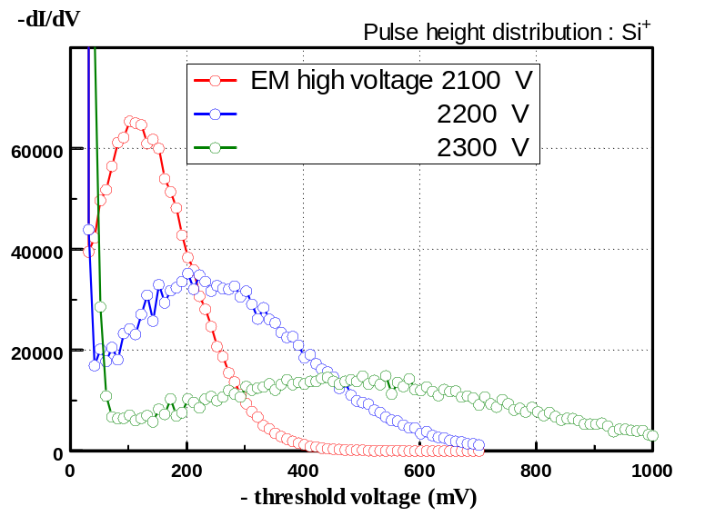
From this set of data, the best setting for the EM high voltage looks to be between 2200 and 2250 V because it provides a well defined valley between the dynamic noise and the useful signal and half of the PHD is beyond 250 mV. A voltage of 2100 V is too low in terms of PHD valley, a voltage of 2300 V does not provide a significant improvement in terms of PHD valley but would reduce the EM life time by yielding to running conditions with a high EM gain.
Contents ↑

Pulse height distribution: mass species effect
For a given secondary extraction voltage, the heavier the species the narrower the PHD and the lower the pulse amplitude corresponding to the PHD maximum. This trend results from the variation of the electron emission at first dynode with respect of the impinging particle velocity. PHD recorded for Si and Ta with a secondary extraction voltage set at 5 kV and no post acceleration voltage are plotted in Fig. 9. These data shows that if, according to the Si PHD, the discriminator threshold is set around -100 mV in order to properly eliminate the dynamic noise contribution, the EM yield will decrease from Si to Ta because with such a threshold value a large part of the pulses for Ta are rejected.
Figure 9 : Species mass effect on the PHD shape
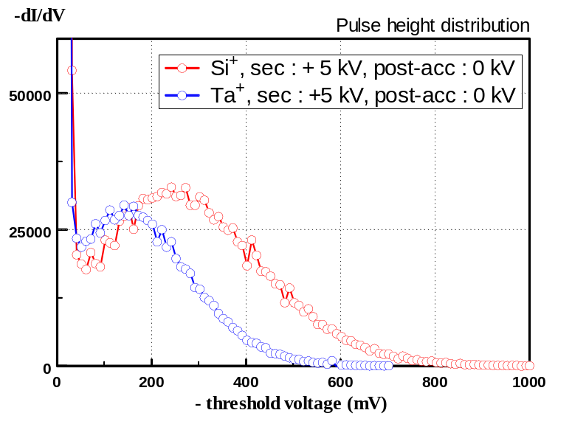
Contents ↑

Pulse height distribution: secondary extraction voltage effect
For a given species, the lower the secondary extraction voltage, the narrower the PHD and the lower the pulse amplitude at the PHD maximum. Fig. 10 shows this secondary extraction effect by comparing PHDs recorded for Si and Ta with two different secondary extraction voltages (5 and 1 kV) and no post acceleration voltage.
Figure 10 : Secondary extraction voltage effect on the PHD shape
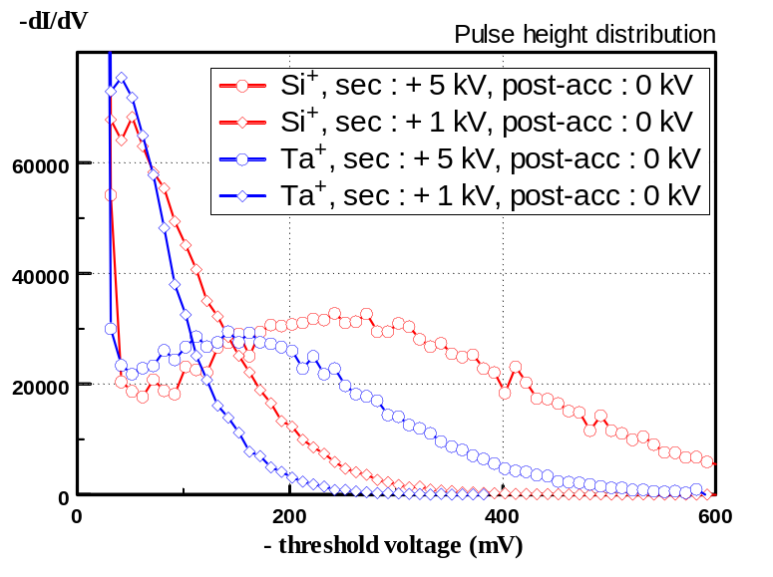
When the secondary extraction voltage decreases, the PHD maximum is shifted towards the low pulse amplitude range and there is no more a well defined PHD valley. These data demonstrate that the setting of the discriminator threshold must be adjusted for every secondary accelerating voltage value, and the optimization between EM yield and low noise level becomes difficult to be determined at low secondary extraction voltages.
Contents ↑

Pulse height distribution: post-acceleration voltage effect
For a given species, the higher the post acceleration voltage, the larger the amplitude of the maximum of the pulse height distribution. Fig. 11 shows the post acceleration effect on Ta⁺ PHD curve at a secondary extraction voltage of 5 kV.
Figure 11 : Post acceleration effect on the PHD shape
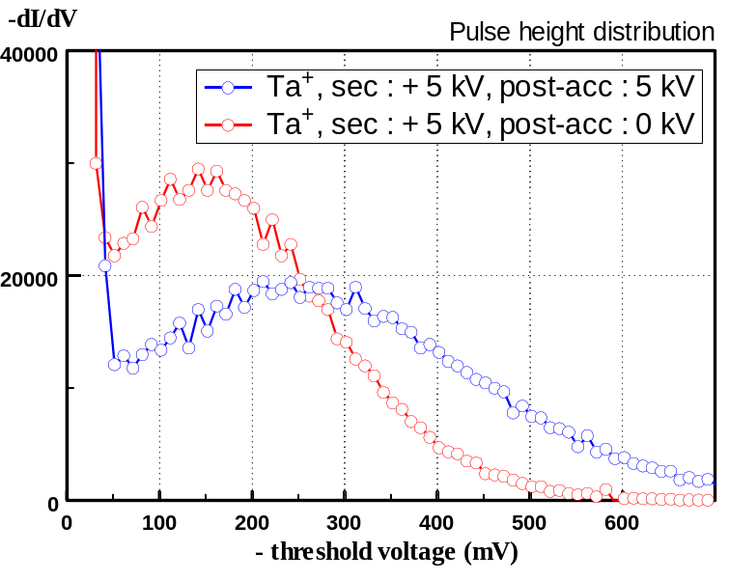
Fig. 12 shows the post acceleration voltage effect on Ta⁺ PHD recorded with a secondary extraction voltage set at 1 kV at 3 different post acceleration voltages.
Figure 12: Post acceleration effect on the PHD shape
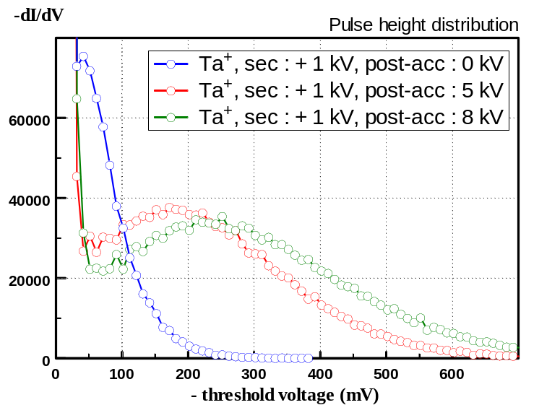
The data plotted in Fig. 12 demonstrate the benefit of the post acceleration effect when running analysis at low secondary accelerating voltage. For Ta and 1 kV secondary extraction voltage, 5 kV post acceleration brings the PHD maximum at the same position as the one measured for 5 kV secondary extraction voltage. It can be also noticed that there is a small difference of the PHD shape between 5 and 8 kV post acceleration voltage. This demonstrates that the ion /electron conversion efficiency reaches a "plateau" when the post acceleration voltage increases and therefore there is no advantage to rise this voltage up to its maximum value. The voltage corresponding to the "plateau" is mass dependent. From data plotted in Fig 11, it can be noticed that, even at high secondary extraction voltage, the shape of the PHD is improved by applying a post-acceleration voltage for heavy species.
Contents ↑

Pulse height distribution record

On CAMECA IMS 7f, all parameters related to the PHD are under computer control. There is a software function which records pulse height distribution, and a function that automatically sets up the EM HV value. These functions are available in all CAMECA IMS 7f software releases, through the Tools program.

Recording a PHD in automatic mode
The procedure for recording a PHD in automatic mode is described below.
- Pre-sputter an area in order to reach a steady state of the secondary ion intensity recorded for the species of interest. It is recommended to use a rastered primary beam with the DTOS gate set at 100%.
- Adjust the secondary beam intensity around 9 10⁵ c/s.
- Check the secondary beam centering on the first dynode (set X and Y deflection to reach center of the intensity plateau in both directions).
- Call the pulse height analyzer (PHA) function by selecting EM PHA in the Tools program.
- Define the acquisition parameters (see hereunder).
- Start the acquisition of a PHD. The PHD curve is displayed during the acquisition. At the end of the acquisition the data can be printed or saved in a template file, which includes the PHD curve and the data.
- At the end of the acquisition mouse click on the PHD graph to set a cursor at the desired value for the discriminator threshold. Click apply to write this value in the keyboard memory. Note that in order to save this parameter in the Setup file, it is necessary to save the ISF file.
Contents ↑

The EM PHA main box

Figure 13 : EM PHA main box.  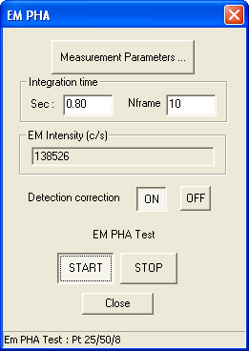 | Measurement parameters: clicking this button opens the editing box Measurement Parameters. The box is opened with the parameter values as they are saved in the setup file.  Integration time displays the time and the corresponding number of frames for the EM signal acquisition, performed before starting a PHA curve acquisition. This parameter is edited in the EM Measurement / Measurement parameters box (see the Tools program users guide). (Setup #44)  EM intensity (c/s) displays the measured EM signal, acquired before starting a PHA curve acquisition.  Detection correction (ON/OFF) switching button for enabling/disabling the EM correction (see the Tools program users guide). It is recommended to set it OFF for the PHA curve acquisition. (Setup #514)  START/STOP Starts or stops the PHA curve acquisition. START opens the PHA curve box containing a graphical window. See section below.  Close returns to the main Tool pad while closing the PHA box.

Contents ↑

The EM PHA Measurement Parameters Box

Figure 14 : EM PHA measurement parameters box.  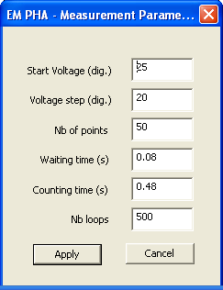 | Start Voltage (dig.) edits the initial EM Threshold of the PHA scan-aquisition routine. Note the conversion coefficient: 1 mV = 2 digits. (Setup #288). Typ.: 50 digits.  Step Voltage (dig.) edits the EM Threshold step of the PHA scan-aquisition routine.. Note the conversion coefficient: 1 mV = 2 digits. (Setup #291). Typ.: 50 digits.  Nb of points edits the number of points of the PHA scan-aquisition routine. (Setup #294). Typ.: 20.  Waiting time (s) edits the time between 2 points of the PHA scan-aquisition routine. (Setup #297). Typ.: 0.08s.  Count time (s) edits the EM counting time for each point of the PHA scan-aquisition routine. (Setup #300). Typ.: 2s.  Apply closes the EM PHA Parameters box and writes the edited parameters in the setup file.  Cancel closes the EM PHA Parameters box without writing the edited parameters in the setup file.

Contents ↑

The EM PHA Curve Box

Figure 15 : EM PHA curve box.  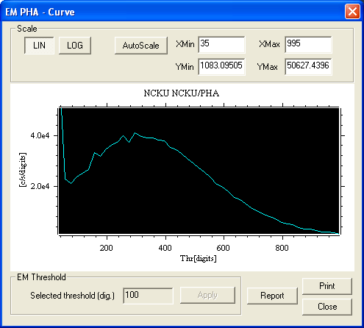 | For the Scale selections and editing field, see the Tools program users guide.  EM Threshold can be set by mouse clicking on the graphical window at the required position. A cursor is then displayed (Setup #36)  Apply writes the EM Threshold edited value to the keyboard.  Report transfers the PHA curve in a template file.
Contents ↑

Post-acceleration tuning

Basic instrument tuning
Preliminary to the tuning of the post acceleration voltage, the setting of the electron multiplier must be checked.

EM high voltage setting
The procedure for setting up the EM HV in automatic mode is described below.
- Select a Si wafer sample.
- Set the secondary acceleration voltage at 5000V. No post acceleration.
- Pre-sputter an area until measuring a constant intensity for ²⁸Si^{+ or -}.
- Check the centering of the secondary beam on the first dynode of the EM. Adjust the count rate around 9e5 c/s.
- Call the EM HV function by selecting EM HV in the Tools program.
- Define the related parameters (see hereunder).
- Start the EM HV automatic adjustment. At the end of the adjustment, the final EM HV is displayed, and automatically written to the keyboard memory. Note that in order to save this parameter in the Setup file, it is necessary to save the ISF file.
Contents ↑

The EM HV main box

Figure 16: EM HV main box.  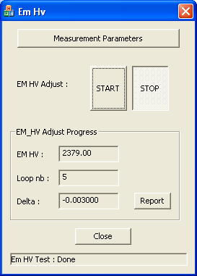 | Measurement parameters: clicking this button opens the editing box Measurement Parameters. The box is opened with the parameter values as they are saved in the setup file.  EM HV adjust (START/STOP) Starts or stops the routine.  EM_HV displays the EM HV value all along the routine completion. (Setup # 37)  Loop nb displays the number of the routine loop in progress.  Delta displays δ which must be smaller and smaller if the routine is converging (see the Tools program users guide).  Close returns to the main Tool pad while closing the EM HV box.

Contents ↑

The EM HV Measurement Parameters Box

Figure 17 : EM PHA measurement parameters box.  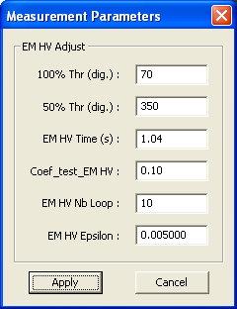 | 100% Thr (digits) edits Threshold(100%), the reference threshold value normally close to the working threshold value. Note the conversion coefficient: 1 mV = 2 digits. (Setup # 261). Typ.: 100 digits.  50% Thr (digits) edits Threshold(50%), the threshold which sets the EM signal at half of the amplitude obtained when the threshold is set at Threshold (100%). Note the conversion coefficient: 1 mV = 2 digits. (Setup # 264). Typ.: 450 digits.  EM HV Time (s) edits the step counting time, corresponding to Threshold(100%) or Threshold(50%) (Setup # 303). Typ.: 1s.  Coeff_test_EMHV edits the routine feedback coefficient. (Setup # 306). Typ.: 0.1.  EMHV_nbloop edits the routine maximum number of loops. (Setup # 309). Typ.: 10.  EMHV Epsilon edits the routine convergence test coefficient δ (Setup # 312). Typ.: 0.005.  Apply writes in the Setup file the Measurement Parameters box modified parameters and closes the box  Cancel closes the box without writing in the setup file the box modified values.
Contents ↑

Principle of the EM HV routine
During the EM HV adjustment routine (iterative procedure), the program automatically performs the following steps:
- The threshold voltage is set at 100% Thr (typ. 100 digits).
- The intensity I_{Si} (thr=100% Thr) is measured.
- The threshold voltage is set at 50% Thr (typ. 450 digits).
- The intensity I_{Si} (thr=50% Thr) is measured.
- The ratio I_{Si} (thr=100% Thr) / I_{Si} (thr=50% Thr) is computed. It should be equal to 2.
  - If it is higher than 2, it means that the EM gain it two low (PHD shifted towards low amplitude) → the EM high voltage is increased, back to step 1.
  - If it lower than 2 it means that the EM gain is high → the EM high voltage is decreased, back to step 1.
  - If it is close enough to 2 (defined by the parameter δ) → the routine stops, the current EM HV value is the final value .
Remark: at the end of the EM voltage adjustment, the secondary beam centering on the first dynode must be checked.
Contents ↑

Threshold setting
Once the EM high voltage has been set following the above procedure, a more accurate setting for the discriminator threshold must be set by recording a PHD curve (see § 5.7)

Post-acceleration setting
It is supposed that the EM voltage and the EM threshold have been tuned according to the procedures described in § 6.1.
- Tune the mass spectrometer for the new secondary accelerating voltage.
- Sputtering a piece of Si, switch on the EM detector a stable signal for Si⁺.
- Increase the post acceleration voltage in order to compensate the loss of energy of the secondary particles. For instance, when the secondary extraction voltage is reduced by 2 kV, the post acceleration must be increased by 2 kV.
- Check the secondary beam centering on the first dynode.
- Use the EM HV routine to set the EM high voltage.
- Record a PHD and set the threshold value at the right value.
- Check the EM yield (by comparison with the FC detector). It should be higher than 80 % for a secondary extraction voltage as low as 500 V.
Remark 1: every time the EM post acceleration voltage is re-adjusted, the secondary beam centering on the first dynode must be checked.
Remark 2: when species with an heavy mass has to be analyzed it worth to record a PHD for this species, and if required to re-adjust the post acceleration voltage to get a better PHD shape (well defined PHD valley).
Contents ↑

Maintenance and troubleshooting

Maintenance
The post acceleration system does not require any special maintenance. The maintenance of the electron multiplier remains the same as without post acceleration.
It is strongly recommended to bake up the secondary ion optics after every mass spectrometer venting operation before re-starting the post acceleration system.
WARNING: In negative mode, the potential of the last EM dynode is the sum of the post acceleration voltage and the EM voltage, which means that it can be as high as 13,000 V. Therefore, never unplugged the EM_HV or the PA_HV connectors when the main gate valve is open.
Contents ↑

Troubleshooting

Problem | Solution
No Post acceleration voltage | -Check the main On/Off switch at the rear of the post acceleration power supply chassis.  - Check the vacuum safety
Very low EM signal compare to FC | -Check the setting of the EM threshold  -Check the setting of the EM voltage
High EM background | -Check the setting of the EM threshold  -Check the setting of the post acceleration voltage
Decrease of the EM signal when the post acceleration voltage increases | -Check the secondary beam centering on the first dynode.  - Check the post acceleration polarity

Contents ↑

